Claremont Bank Surgery Patient Group Meeting 17.04.19

Present:
Jane Read (Practice Manager), Dr Fallon(GP Partner), Emily Marston (Deputy Practice Manager), Marilyn Priddey, Wendy Jenkinson, Sheila Dench, Pam Coli.
Apologies:
Liz Hector, Becky Kelly, Anne-Marie Smith,

- Minutes of last meeting
- Matters arising

Agenda Items

- Darwin Health – Marilyn
Darwin Health is a group of practices in Shrewsbury coming together to work collaboratively to provide routine GP and Nurse appointments on weekday evenings and weekends. Can now do smear tests and health checks.

- Primary Care Networks
Practices need to be part of a primary care network by the 1st of July. Another way in which practices are being asked to work collaboratively, for example, sharing different types of practitioners like Physiotherapists etc. We will know more about how this will affect our surgery at the next meeting.

- NHS 111 – appointments in practice
By July, NHS 111 will have access to our system to book 2 appointments a day for patients that ring the evening before. Again will be able to feedback more on this at the next meeting.

- April 2019 >25% appoinments should be online
We’ve had a 6% increase in demand compared to the same time last year – currently have 1500 patients who have an online access account.

- Online Access Problems – Sheila
What is a general appointment?
- Shows as a general appointment because it is a routine bookable slot. – It used to say ‘Online appointment’ however due to online consultations on the horizon this may become confusing.
Booking appointments
- Over the Easter period there are fewer online appointments available to book as the majority are reserved for emergency cases. I have since amended the online message to include this information and will continue to do so when it is a bank holiday or exceptionally busy period.
- The one appointment you could see was the only available in the 2 week period which you can book up to. We have seen a big increase in the demand for online appointments.
Password issue
- I have a couple of ‘dummy’ accounts which I use to test the patient access system and have not encountered this problem so would suggest contacting the support team.

- Online Consultations to be available by July 2019 – (where IT allows)

- Fax machine switch off by March 2020
Claremont Bank is aiming to stop using the fax machine at the end of July this summer and will also be finding ways to go ‘paper light’. For example by utilising the surgery email.
‘GP practices will not be allowed to buy fax machines from January next year and will not be allowed to use them beyond March 2020, the health secretary has announced.
The measure, which is part of the Government’s technology vision for the health service, will see NHS organisations being monitored on a quarterly basis until they are fully ‘fax free’.
Organisations will have to invest in modern technology, such as secure emails, to improve cyber security, the Department of Health and Social Care (DHSC) said.
Health secretary Matt Hancock said: ‘I am instructing the NHS to stop buying fax machines and I’m setting a deadline for getting rid of them altogether.
'Email is much more secure and miles more effective than fax machines. The NHS can be the best in the world – and we can start with getting rid of fax machines.’
- QOF – Maximum points achieved
The Quality Outcome Framework measures how effectively the surgery invites patient on long term health registers in for appointments which monitor their condition.
- Summary Care Record Collection
See handout. Summary Care Records (SCR) are an electronic record of important patient information, created from GP medical records. They can be seen and used by authorised staff in other areas of the health and care system involved in the patient's direct care.
NHS Digital have asked practices to actively seek consent from patients as to what they’re preference is. There are 3 options for patients:
- Standard – includes - current medication - allergies and details of any previous bad reactions to medicines - the name, address, date of birth and NHS number of the patient
- Additional - significant medical history (past and present) - reason for medication - anticipatory care information (such as information about the management of long term conditions) - end of life care information (from the SCCI1580 national dataset) – immunisations
- Dissent – no consent for a SCR

- Accessible Information Standard
The AIS is a piece of legislation aimed at improving the way primary care organisations communicate with patients.
Number of training sessions booked throughout the year:
- British Sign Language
- Deaf Awareness
- Dementia Awareness
We have also made simple Makaton signs available at Reception, added an alternative format message onto letters we send out and put the hearing loop out permanently on the front desk.
Any other suggestions?
- Carer Health Check invitations
We have started inviting carers who are not eligible for an NHS health check due to their age into the surgery to have an annual ‘MOT’ with a practice Nurse. Also gives a chance for onward referrals to either our Care Coordinator or Social Prescriber.
- LGBT Practice
Please see hand out. A few members of staff have attended a LGBT training day, we are in the process of becoming an RCGP member of ‘Pride in practice’, eg. not using ‘Titles’ on booking in screen.

- POD savings
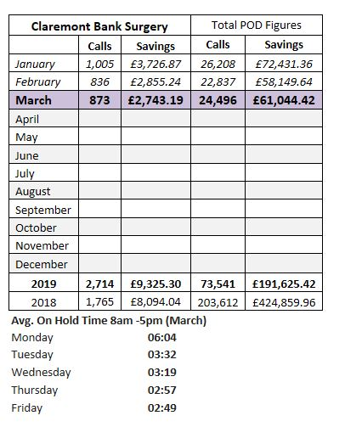

- New Staff members
Dr Angela Jones, we’ll be introducing her on our next newsletter and have done so on our website as well.
‘I qualified in 1992 from Nottingham University Medical School and completed my GP training in Chester. Since then I have been working as a GP in Nottingham and then in Shrewsbury. I moved to Shrewsbury with my family when my husband began work as a consultant at the hospital in 2003. When I’m not working I enjoy spending time with my family.’
Dr Prabesh Shahi (ST2) – Specialty Training Doctor – 2nd year
Clare Walker – Admin
- Riverside New Surgery – Home for Phlebotomy – Liz.
Liz asked that this be put on the agenda as she had noticed the new surgery being built next to us and the hope that they might have a room for a Phlebotomist that we may be able to access. We have received no news on this matter, but will feedback as soon as we have any information.
- We are now a Park Run Practice
Dr Eardley has arranged for the Surgery to be a recognised supporter of Park Run. We had a great turn out of staff wanting to join up.
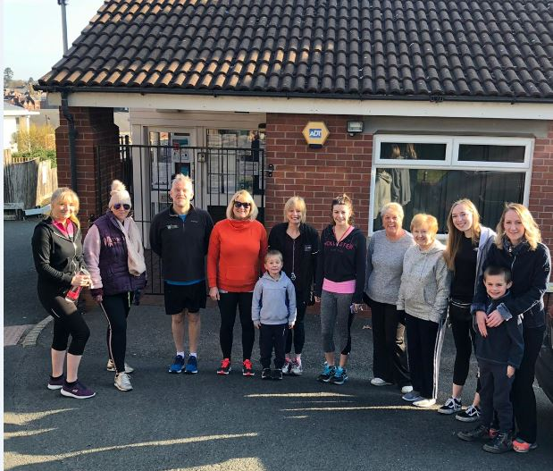

- Social Prescribing Update

Referrals for Claremont Bank Surgery
Total = 21

Age ranges:  10-19 1  20-29 0  30-39 0  40-49 3  50-59 4  60-69 7  70-79 5  80-89 1  90-99 0 | Reasons for opportunistic referral (can be referred for more than one reason)  Risk of loneliness / isolation – 2  Frequent attender – 0  Mental health difficulties – 4  Carer – 1  Long term conditions – 3  Lifestyle risk factors - 18  Other – 0

People seen:
21 people seen. Referrals have been made to Age UK, Enable, Energise, Lifestyle Fitness, Leisure Centre, Shropshire RCC, Help2Slim, Help2Quit, MIND and Through the Doorway. Clients have also been signposted to other local activities.

- Friends and Feedback
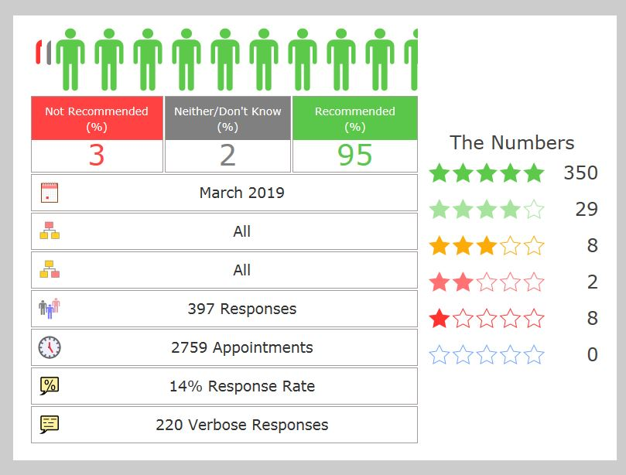

Comments
- Polite reception, knowledgeable staff, kindly expert GP. Can't be bettered.
- Darn good surgery and even better staff. I know that I will be well cared for.
- All staff, from reception to the doctors are helpful, kind and and polite. I have 100% confidence in all the team.
- Always treated with compassion dignity & respect. I always recommend Claremont bank surgery to others.

AOB

Date of next meeting Wednesday 17th July.

